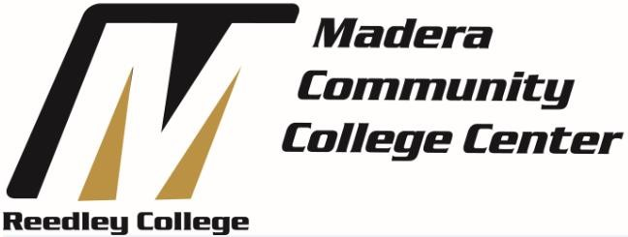
Business Advisory Committee
Meeting Minutes
March 21, 2019
Time: 4:00PM Present:
• Members: Aaron Corson, Adrian Gutierrez, Michael Martinez, Davene Munoz, John Pape • Faculty/Administration: Alan Cade, David Kuhtz, Ganesan Srinivasan

Next meeting: Fall 2019

- Announcements
  - Welcome and Introductions

- Discussion
  - What is an Advisory Committee
  - Functions and Duties of an Advisory Committee
  - Operation of Advisory Committee
  - Current Associate Degree and Certificate Programs o Accounting
    - Business

  - The Advisory Committee approved the addition of the 21st Century Skills Certificate of Achievement by unanimous vote (5 – 0)

  - Current College Goals o Accreditation by Spring 2020 o Guided Pathways

  - Organizing Committee – For next meeting the committee will need to:
    - Elect a chairperson and recorder by next meeting o Determine rotation for advisory members
    - Develop rules for operating committee

  - Future Actions of the committee will be:
    - Members will become familiar with instructional programs o Assist with development of short and long range goals for program o Identify areas of concerns, program needs, and ways members can contribute to solutions
    - Prepare an annual report on activities and accomplishments

Adjourn at: 5:10pm
Submitted by: David Kuhtz, Business Department Instructor

